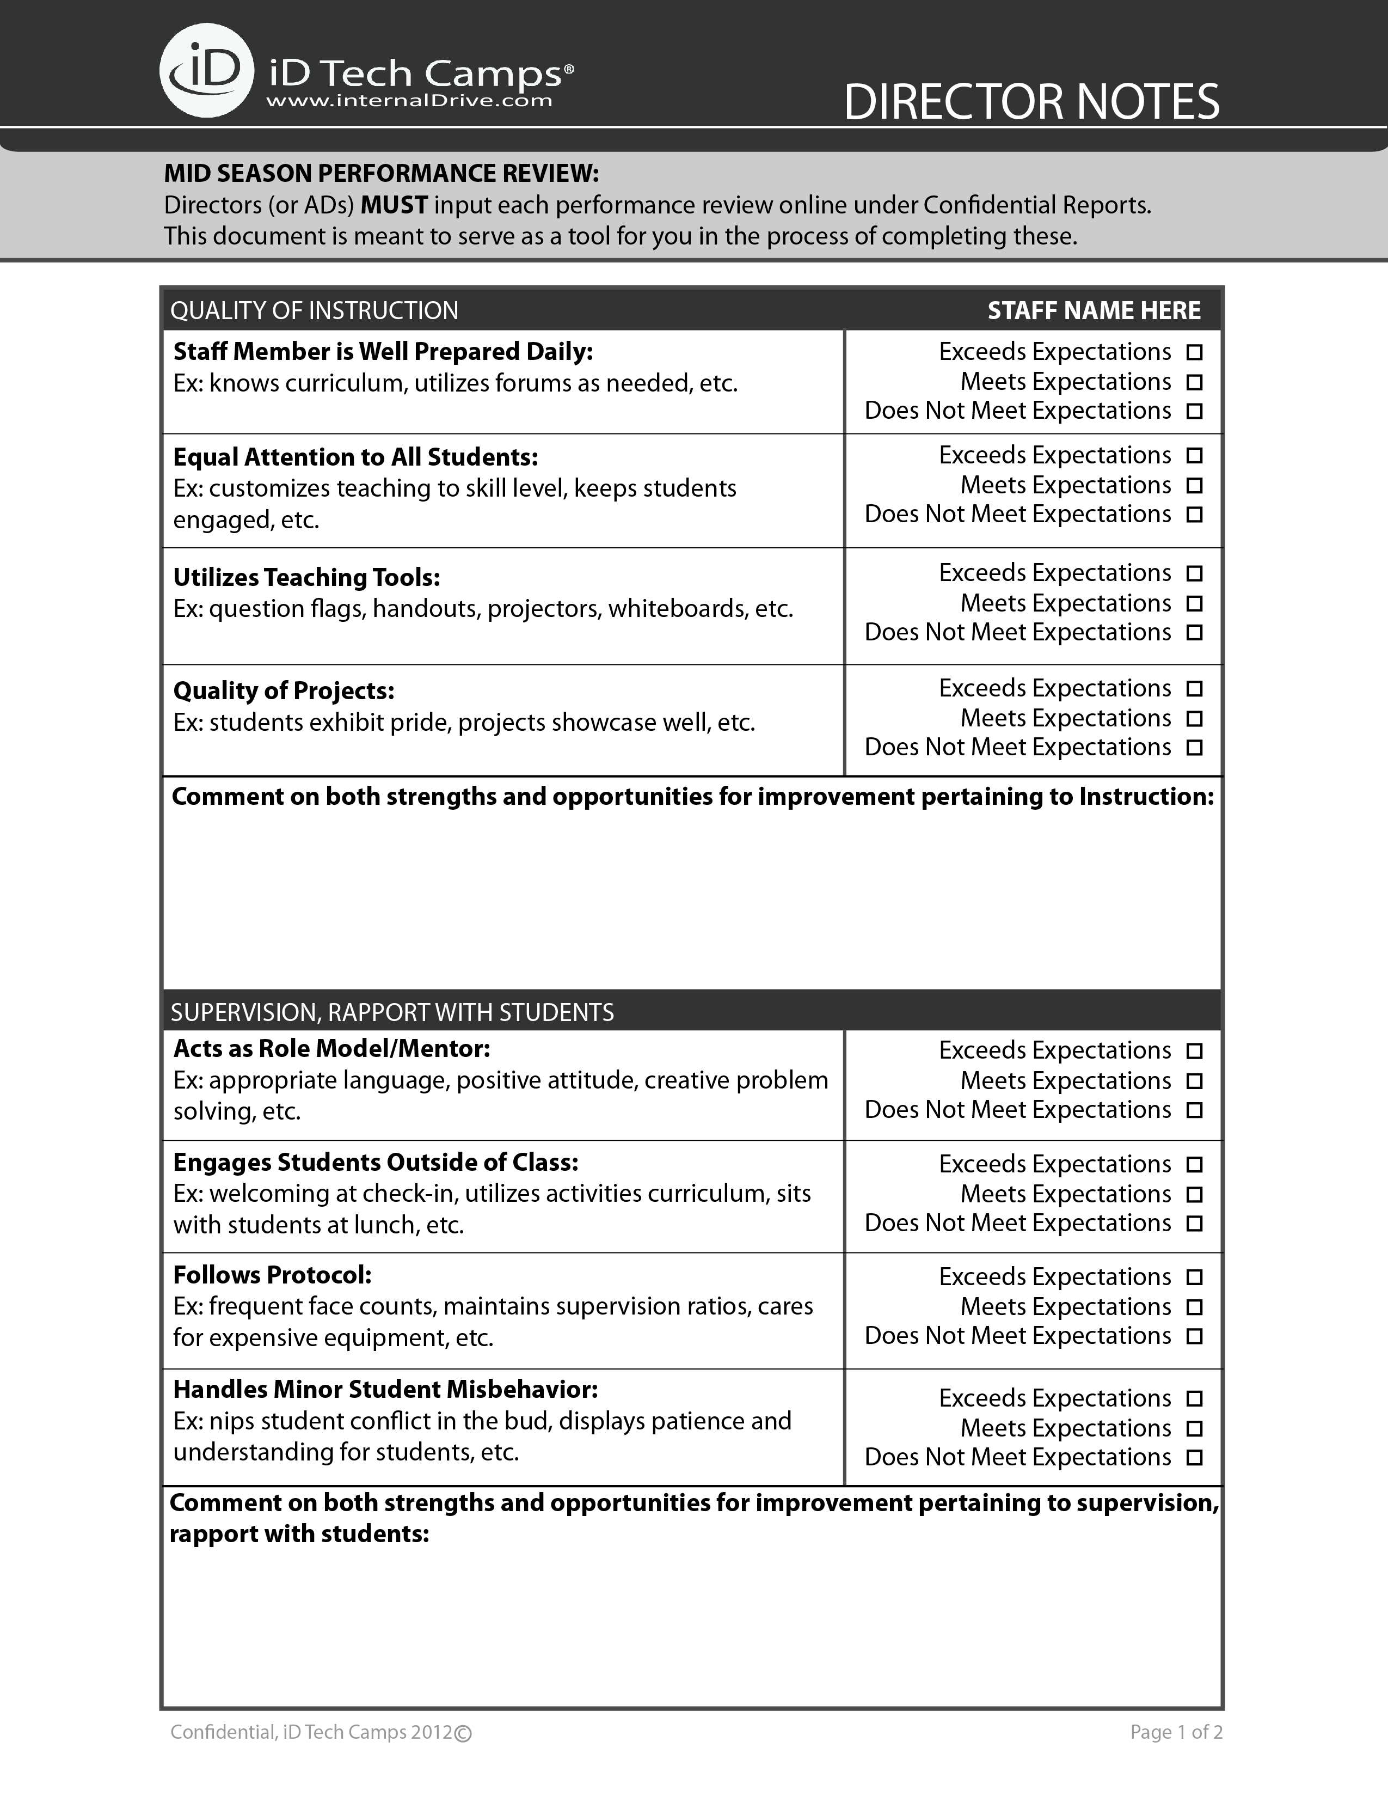

NOTES:

NOTES:

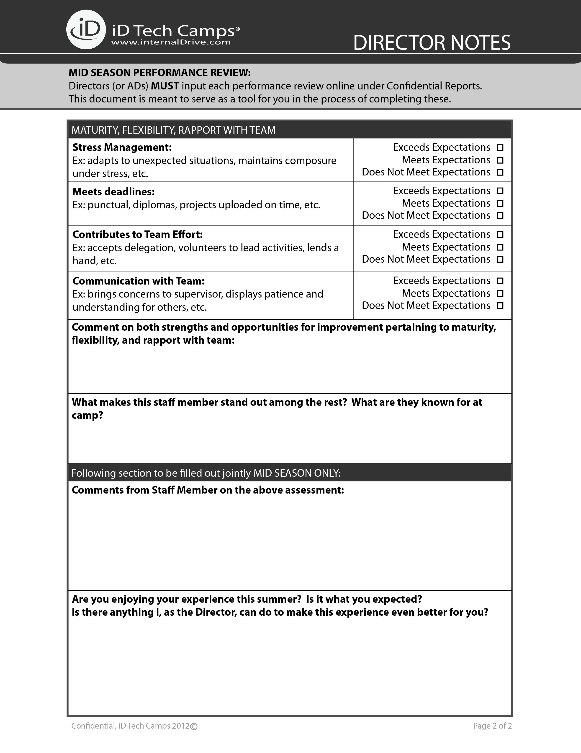

NOTES:

NOTES:

NOTES:

NOTES: